

Comparative Analysis of DevOps and Waterfall Methodologies in Software Development

Mr. Payman Ghorbani 12700830

Launching into Computing

University of Essex Online

01 September 2025

Dr. Samuel Danso

Contents
Table of Figures 2
List of Appendices 3
Introduction 4
Methodology Comparison and Analysis (DevOps vs. Waterfall) 4
References 7
Appendices 8
Appendix A: Microsoft Azure CI/CD architecture 8

Table of Figures
Figure 1 CI/CD Architecture using Azure Pipelines 4

List of Appendices

Appendix A: Microsoft Azure CI/CD Architecture………………………………………………………………………… 7

Introduction
Software engineering goes far beyond simply writing codes. It’s a structured process that applies engineering principles to the design, development, testing, and upkeep of software systems. By following a clear framework, often referred to as the Software Development Life Cycle (SDLC).
The way a software team approaches development can have a significant impact on how projects progress from planning to final delivery. The chosen methodology influences the organisation of work, the management of risks, and the team’s adaptability to changes. Waterfall and DevOps are two fundamentally different models that each have their advantages and disadvantages, depending on the context (Rao et al. 2025). This report compares these methods based on their flexibility, how well they fit with projects, and managing risks. It utilises information from both the business world and academics to recommend the best ways to use it.

Methodology Comparison and Analysis (DevOps vs. Waterfall)
The Waterfall is a sequential approach in which each phase must be finished before the next one can start (Royce, 1970). According to UoEO (2025), this structure makes it easier to plan and keep track of everything; however, it is harder to adapt to changes. This means adding new requirements is expensive and causes issues after starting the development. Consequently, Waterfall methodology best suits projects with stable and defined objectives, like projects in healthcare, government, and aerospace.

As highlighted in UoEO (2025), Waterfall methodology is most effective for large-scale projects involving multiple stakeholders and regulatory requirements due to its structured documentation and sequential workflow. Therefore, it emphasises the importance of thorough, upfront planning to ensure all team members are aware of their tasks and responsibilities. This reduces the risks; however, deferring testing until later stages means that issues only surface late in SDLC, potentially resulting in costly rework or system failure. The 2025 CrowdStrike incident shows how important is to test and maintain Waterfall-style SDLC.

In contrast, DevOps is an innovative methodology that integrates software development (Dev) and IT operations (Ops) and is based on automation. It facilitates continuous integration (CI), continuous deployment (CD), and monitoring, thus accelerating software delivery, and allowing immediate feedback (Microsoft, 2025). ISACA (2022) claims that DevOps is highly flexible, enabling teams to swiftly respond to changes in user requirements and system performance. However, significant finances are required for the infrastructure, automation tools, and changing the company's culture.
As highlighted in UoEO (2025), DevOps works well for large, cloud-based apps that need continuous availability and frequent changes. Amazon and Netflix deploy updates many times per day, ensuring the rapid emergence of new concepts and seamless user experiences.
Microsoft (2025) argues that automated testing and deployment with tools such as Jenkins, Azure Pipelines (see Appendix A for full architecture diagram) and Spinnaker significantly reduce the number of user errors and enhance system reliability.

Moreover, Google AI Research (2023) states that real-time monitoring and anomaly detection enable teams to proactively identify and resolve issues. DevOps also facilitates chaos engineering, intentionally introducing failures into systems to evaluate and improve fault tolerance and recovery time. It is also claimed that risk management is embedded at every stage through automation, monitoring, and rollback mechanisms.
Conclusion
In essence, DevOps and Waterfall represent two different paradigms that are influenced by risk tolerance, project requirements, and flexibility or adaptability. Waterfall works best in regulated and stable environments, while DevOps empower rapid iteration and continuous delivery.
Company objectives must be aligned with technical strategies and operational context to choose the best methodology. When applied appropriately, each model enhances software reliability, long-term value, and stakeholder confidence.

References

- Google AI Research (2023) AI-Assisted Software Development & Testing. Available at: https://ai.googleblog.com
- ISACA (2022) The Role of DevOps in Enterprise IT Governance. Available at: https://www.isaca.org
- Microsoft (2025) CI/CD baseline architecture with Azure Pipelines. Available at: https://learn.microsoft.com (Accessed: 29 August 2025).
- Rao, D.B. et al. (2025) A Comparative Analysis of Software Development Models: Waterfall, Agile and DevOps. In: Intelligent Systems and Sustainable Computing. Springer. Available at: https://link.springer.com/chapter/10.1007/978-981-97-8355-7_51
- Royce, W.W. (1970) Managing the Development of Large Software Systems. Proceedings of IEEE WESCON, 26, pp.328–388.
- University of Essex Online (2025) Fundamentals of Software Engineering. Available at: https://www.my-course.co.uk (Accessed: 28 August 2025).

Appendices

Appendix A: Microsoft Azure CI/CD architecture
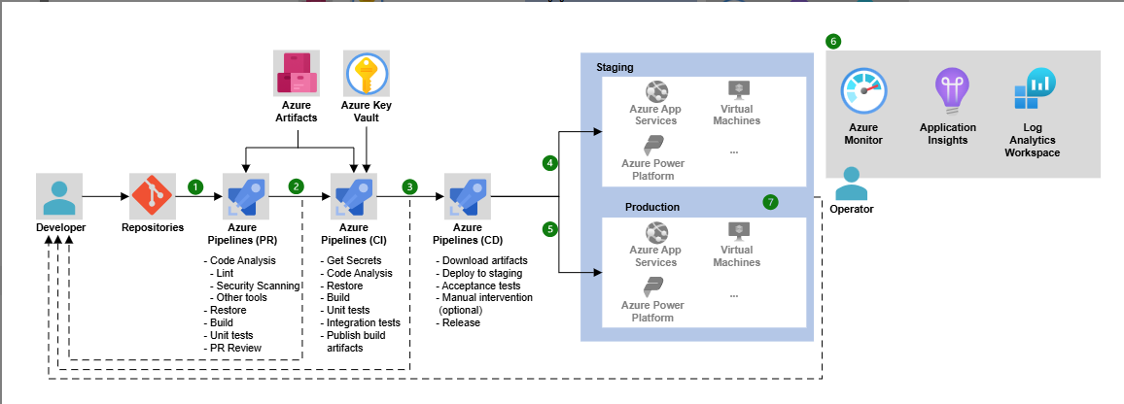
Figure 1. CI/CD architecture using Azure Pipelines, illustrating the flow from pull request validation to production deployment, including monitoring and feedback loops.

Regarding Azure DevOps:
Azure Pipelines is a full CI/CD framework for making changes to both applications and infrastructure as code (IaC). There are PR pipelines for checking things before they are merged, CI pipelines for testing and making artefacts, and CD pipelines for deploying things in stages and releasing them to production. Azure Repos Git, Artefact Feeds for managing the lifecycle of packages, and Key Vault for safely storing secrets are some of the most important parts. Azure Monitor, Application Insights, and Log Analytics are all tools that can be used to keep an eye on things. Deployment targets include Azure Functions, App Services, AKS, and Container Apps. YAML pipelines and templates make it easier to reuse code and keep track of different versions. Self-hosted agents make it possible to build code securely or in large quantities. Some of the benefits are shorter release cycles, better code quality, less risk during deployment, and automatic rollbacks. The architecture follows the Azure Well-Architected Framework and uses RBAC, tokenisation, and dependency scanning to improve operations, lower costs, and improve security (Microsoft, 2025).

SDLC Including 6 phases: 1- Requirement Analysis, 2-desig 3-implementation 4-Testng 5-Deployment 6-Maintenanca and updates
In July 2025, a faulty update from CrowdStrike, a leading cybersecurity firm, triggered widespread system crashes — the infamous “blue screens of death” — across multiple industries. The aviation sector was hit especially hard

